Tabish Parkar

Summative Assessment 1:

Systems Analysis and Design

05HA2309970 Bellville

System Development Life Cycle for the Local Elderly Care Centre App

**Investigation Phase**

* Why is the system being designed?
* The system looks to better the quality of elderly care by providing caregivers with optimised management tools for scheduling, medication tracking, wellness activities and real-time health monitoring via wearable devices. It also supervises the family involvement aspect and ensures timely alerts for vital health events.
* Who will be using the system?
* Primary users include caregivers at the elderly care centre, elderly residents and family members. Secondary users may include the healthcare professionals and administrative staff.
* What capabilities will the system provide?
* The system will allow for elderly care management, appointment scheduling, medication tracking, integration with wearable health devices, real-time alerts for critical health events and family access for monitoring.

**Feasibility Study**

* Statement of the Problem:
* Elderly residents often need constant health monitoring and coordinated care, which is challenging with manual processes and is limited real-time data access. This allows for a delayed response to health emergencies and insufficient management.
* Preliminary Investigation and Summary of Findings:
* Paper-based systems and Manual record-keeping methods are insufficient and are prone to errors. Wearable health devices can allow for real-time data but are lacking integration and alert mechanisms. An integrated digital system can improve responsiveness and coordination.

Timeline/Gantt Chart:

| Phase | Duration | Start Date | End Date |

|---------------------------|----------------|--------------|------------|

| Requirements Gathering | 2 weeks | 01/02/2025 | 14/02/2025 |

| System Design | 3 weeks | 15/02/2025 | 07/03/2025 |

| Development & Testing | 6 weeks | 08/03/2025 | 18/04/2025 |

| Deployment & Training | 2 weeks | 19/04/2025 | 02/05/2025 |

**Analysis Phase**

* Procedure for collecting data:
* Interviews with caregivers, elderly residents, and family members.
* Observation of current workflows.
* Review of existing health records and device data logs.
* Defining System Requirements:
* User authentication for caregivers, residents, and family members.
* Scheduling module for appointments and wellness activities.
* Medication management with reminder alerts.
* Integration with wearable health devices (heart rate, blood pressure, oxygen levels).
* Real-time alerts for abnormal health metrics.
* Dashboard for health data visualization.
* Secure access for family members to monitor elderly residents.
* Prioritization of Requirements:
* High Priority: Real-time health monitoring, alerts, caregiver management.
* Medium Priority: Scheduling and medication management.
* Low Priority: Advanced analytics and reporting.

**Design Phase**

**Context Diagram:**

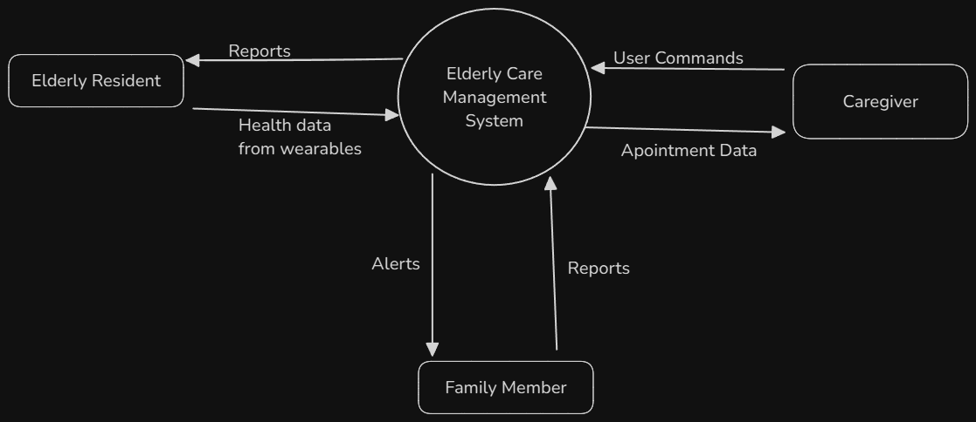

**Flow Chart:**

**Use Case Diagram:**

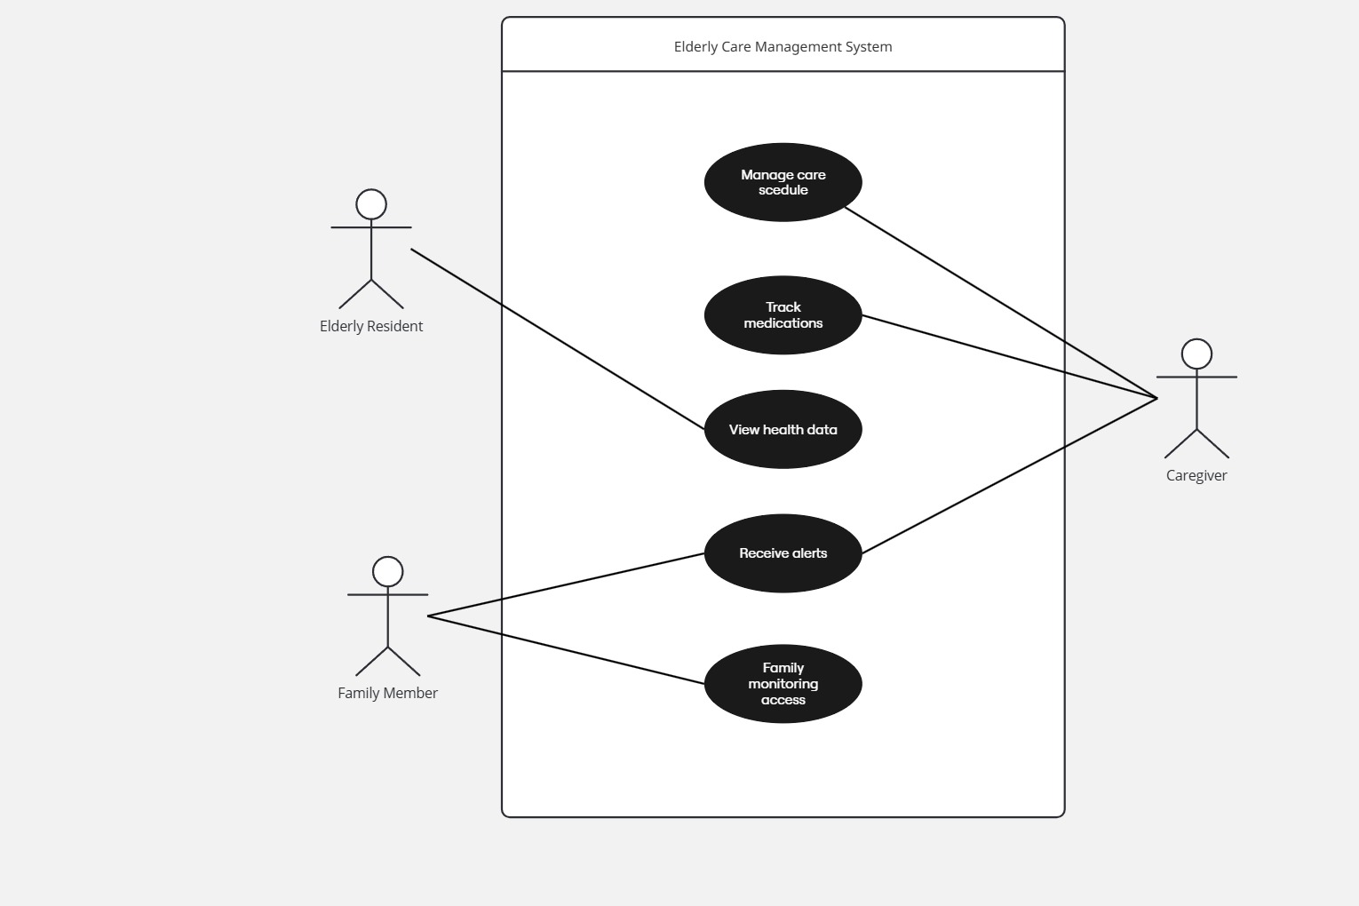

**Sequence Diagram:**

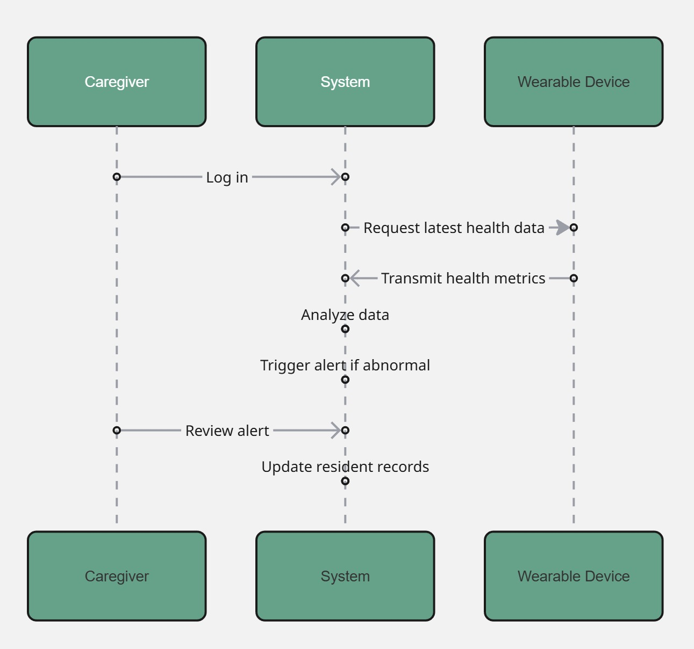

**Activity Diagram:**

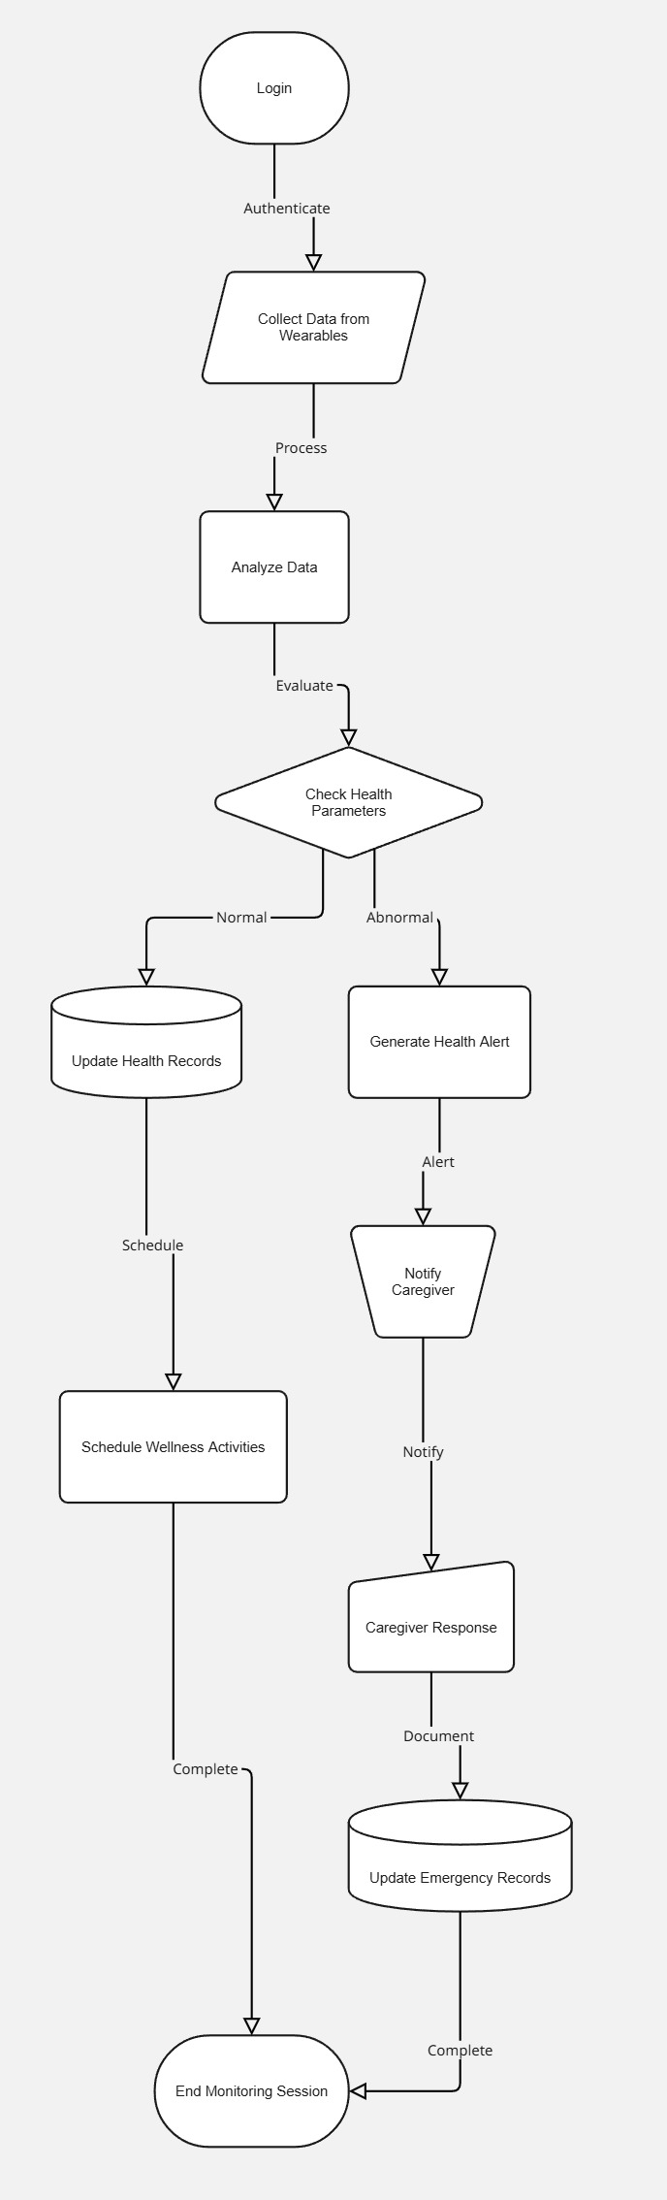

**Class Diagram:**

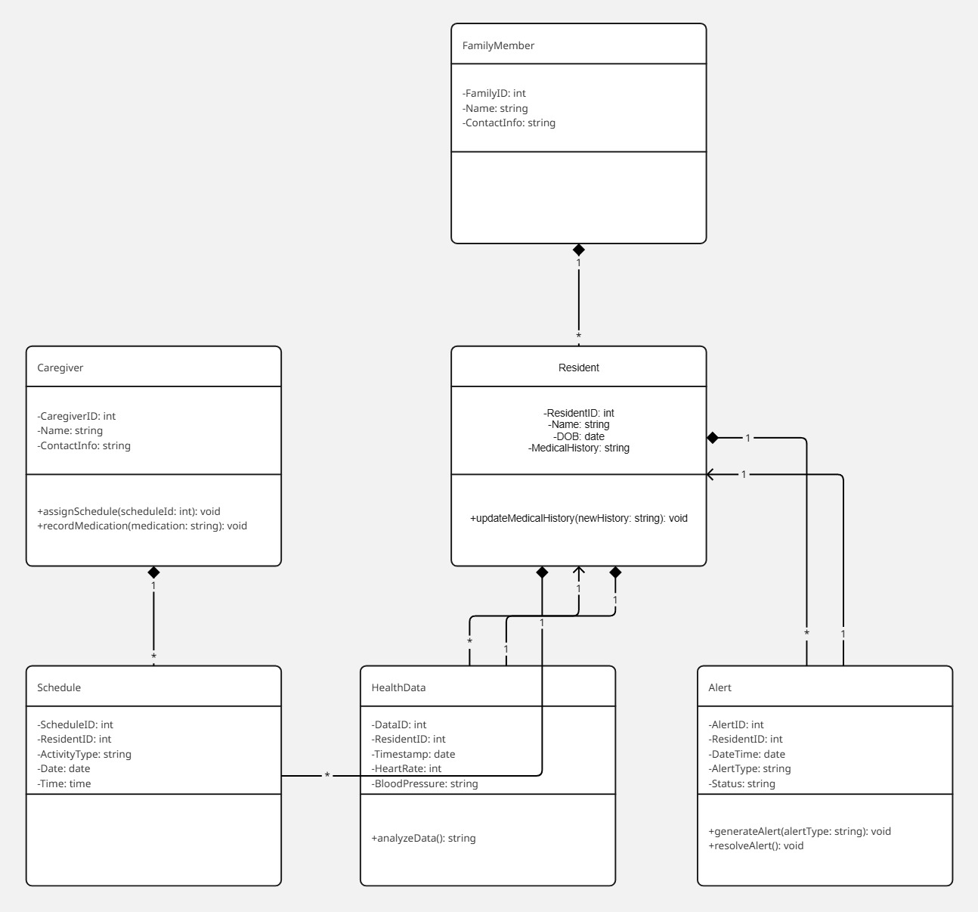

- UI Design:

* Home screen with various login options for caregiver, resident and family.
* Dashboard showing health metrics, alerts, and schedules.
* Data entry methods for medication and activity management.
* Notification panel for alerts.

- Design Considerations:

* Simple, intuitive navigation for elderly users.
* Secure login with multi-factor authentication.
* Responsive interface for various devices and operating systems.

**Implementation Phase**

Technology:

* Frontend - React.js for responsive and dynamic user interfaces.
* Backend - Node.js with Express.js for the server-side logics.
* Database – MySQL or MongoDB for flexible data storage.
* Wearable Device Integration - RESTful APIs for device data tracking.
* Security - OAuth 2.0 for authentication, SSL/TLS for data transmission.
* Alerts & Notifications - Firebase Cloud Messaging for real-time alerts.
* Hosting - Cloud services like AWS or Azure for scalability when needed.

Summary:

This well-structured SDLC plan allows for the development of an effective, secure and user-friendly elderly care management system that uses modern technologies and integrates real-time health monitoring to improve elderly residents' well-being and family involvement.